**A**

## NON-SYLLABUS PROJECT REPORT

## ON

**AI GESTURE CONTROLLED MOUSE**

## Submitted in partial fulfillment of requirements

## for the award of the Degree of

## Bachelor of Technology

## of

## Poornima University, Jaipur



**Session: 2021-2022**

### Submitted By:

### NAME: Noel William, Aditya Rai, Sanket Swaroop, Anirban Biswas

**REG NO.**: 2021PUSCEBADX09221, 2021PUSCEBCEX09292,

2021PUSCEBADX09552, 2021PUSCEBADX09933

### Submitted To:

### School of Computer Science and Engineering, Poornima University

**IS-2027-2031, Ramchandrapura, P.O. Vidhani Vatika, Sitapura Extension,**

**Jaipur, Rajasthan(India) 303905.**

# CANDIDATE’S DECLARATION

We hereby declare that the work presented in the major project report entitled “**AI GESTURE CONTROLLED MOUSE**” is submitted by **Noel William(2021PUSCEBADX09221)** is in the fulfillment of the requirements for the award of the degree of Bachelors of Technology, Poornima University, Jaipur. The work has been found satisfactory, authentic of my own work carried out during my degree, and approved for submission.

The work reported in this has not been submitted by me for the award of any other degree or diploma.

**Date : 10/04/22**

**Name:**  Noel William

Aditya Rai

Anirban Biswas

Sanket Swaroop

### CERTIFICATE

This is to certify that the major project report entitled “**AI GESTURE CONTROLLED MOUSE**” is submitted by **Noel William (2021PUSCEBADX09221), Aditya Rai (2021PUSCEBCEX09292), Anirban Biswas (2021PUSCEBADX09933), Sanket Swaroop (2021PUSCEBADX09552)** students of 1st year Ist semester in partial fulfillment of the degree of Bachelors of Technology, Poornima University, Jaipur during the academic year 2021-2023. The work has been found satisfactory and is approved for submission.

### Abhilasha Khandelwaal

Guide

SCE

### 

HOD BTech

First Year Dean SCE

SCE

### ACKNOWLEDGEMENT

It is our privilege to express our sincerest regards to our project coordinator, **Mr. Parminder Singh,** for his valuable inputs, able guidance, encouragement, whole-hearted cooperation, and constructive criticism throughout the duration of our project. Many thanks to our project guide, **Abhilasha Khandelwaal** (Asst. Professor), who has given his full effort in guiding the team for achieving the goal as well as his encouragement to maintain our progress on track.

We would like to express our heartfelt appreciation to all faculty members whose direct or indirect suggestions helped us to develop this project. We pay our respect and love to our parents and all other family members and friends for their love and encouragement throughout our careers.

**Noel William (2021PUSCEBADX09221)**

### ABSTRACT

Researchers around the world are now focused on to make our device more interactive and trying to make the devices operational with minimal physical contact. In this research, we propose an interactive computer system which can operate without any physical mouse. This system can be beneficial to everyone, especially to the paralyzed people who face difficulties to operate physical mouse. We have used Artificial Intelligence to navigate mouse controlling system. Once the user is in mouse controlling mode, user can perform all the mouse operations only by showing different number of fingers.The mouse is one of the wonderful inventions of Human-Computer Interaction (HCI) technology. Currently, wireless mouse or a Bluetooth mouse still uses devices and is not free of device completely since it uses a battery for power and a dongle to connect it to the PC. In the proposed AI virtual mouse system, this limitation can be overcome by employing webcam or a built-in camera for capturing of hand gestures and hand tip detection using computer vision. The algorithm used in the system makes use of the machine learning algorithm. Based on the hand gestures, the computer can be controlled virtually and can perform left click, right click, scrolling functions, and computer cursor function without the use of the physical mouse. The algorithm is based on deep learning for detecting the hands. Hence, the proposed system will avoid COVID-19 spread by eliminating the human intervention and dependency of devices to control the computer.

**Table of Contents**

Front Page i

CANDIDATE’S DECLARATION ii

CERTIFICATE iii

ACKNOWLEDGEMENT iv

ABSTRACT v

Table of Contents vi

List of Figures viii

List of Tables ix

Chapter 1 Introduction

Chapter 2 Working of project

Chapter 3 Result analysis

Chapter 4 Future Scope

Chapter 5 Conclusion

References

**INTRODUCTION**

With the development technologies in the areas of augmented reality and devices that we use in our daily

life, these devices are becoming compact in the form of Bluetooth or wireless technologies. This paper

proposes an AI virtual mouse system that makes use of the hand gestures and hand tip detection for

performing mouse functions in the computer using computer vision. The main objective of the proposed

system is to perform computer mouse cursor functions and scroll function using a web camera or a built-in

camera in the computer instead of using a traditional mouse device. Hand gesture and hand tip detection by

using computer vision is used as a HCI [1] with the computer. With the use of the AI virtual mouse system,

we can track the fingertip of the hand gesture by using a built-in camera or web camera and perform the

mouse cursor operations and scrolling function and also move the cursor with it.

While using a wireless or a Bluetooth mouse, some devices such as the mouse, the dongle to connect to the

PC, and also, a battery to power the mouse to operate are used, but in this paper, the user uses his/her built-

in camera or a webcam and uses his/her hand gestures to control the computer mouse operations. In the

proposed system, the web camera captures and then processes the frames that have been captured and then

recognizes the various hand gestures and hand tip gestures and then performs the particular mouse function.

Python programming language is used for developing the AI virtual mouse system, and also, OpenCV which

is the library for computer vision is used in the AI virtual mouse system. In the proposed AI virtual mouse

system, the model makes use of the MediaPipe package for the tracking of the hands and for tracking of the

tip of the hands, and also, Autopy packages were used for moving around the window screen of the computer

for performing functions such as left click, right click, and scrolling functions. The results of the proposed

model showed very high accuracy level, and the proposed model can work very well in real-world

application with the use of a CPU without the use of a GPU.

**Working Of Project**

**Algorithm used for Hand Tracking**

For the purpose of detection of hand gestures and hand tracking, the MediaPipe framework is used, and

OpenCV library is used for computer vision. The algorithm makes use of the machine learning

concepts to track and recognize the hand gestures and hand tip.

##### MediaPipe

MediaPipe is a framework which is used for applying in a machine learning pipeline, and it is an opensource

framework of Google. The MediaPipe framework is useful for cross platform development since the

framework is built using the time series data. The MediaPipe framework is multimodal, where this

framework can be applied to various audios and videos . The MediaPipe framework is used by the

developer for building and analyzing the systems through graphs, and it also been used for developing the

systems for the application purpose. The steps involved in the system that uses MediaPipe are carried out in

the pipeline configuration. The pipeline created can run in various platforms allowing scalability in mobile

and desktops. The MediaPipe framework is based on three fundamental parts; they are performance

evaluation, framework for retrieving sensor data, and a collection of components which are called calculators

, and they are reusable. A pipeline is a graph which consists of components called calculators, where

each calculator is connected by streams in which the packets of data flow through. Developers are able to

replace or define custom calculators anywhere in the graph creating their own application. The calculators

and streams combined create a data-flow diagram; the graph is created with MediaPipe where

each node is a calculator and the nodes are connected by streams.

**Mediapipe Hand Recognition Graph**

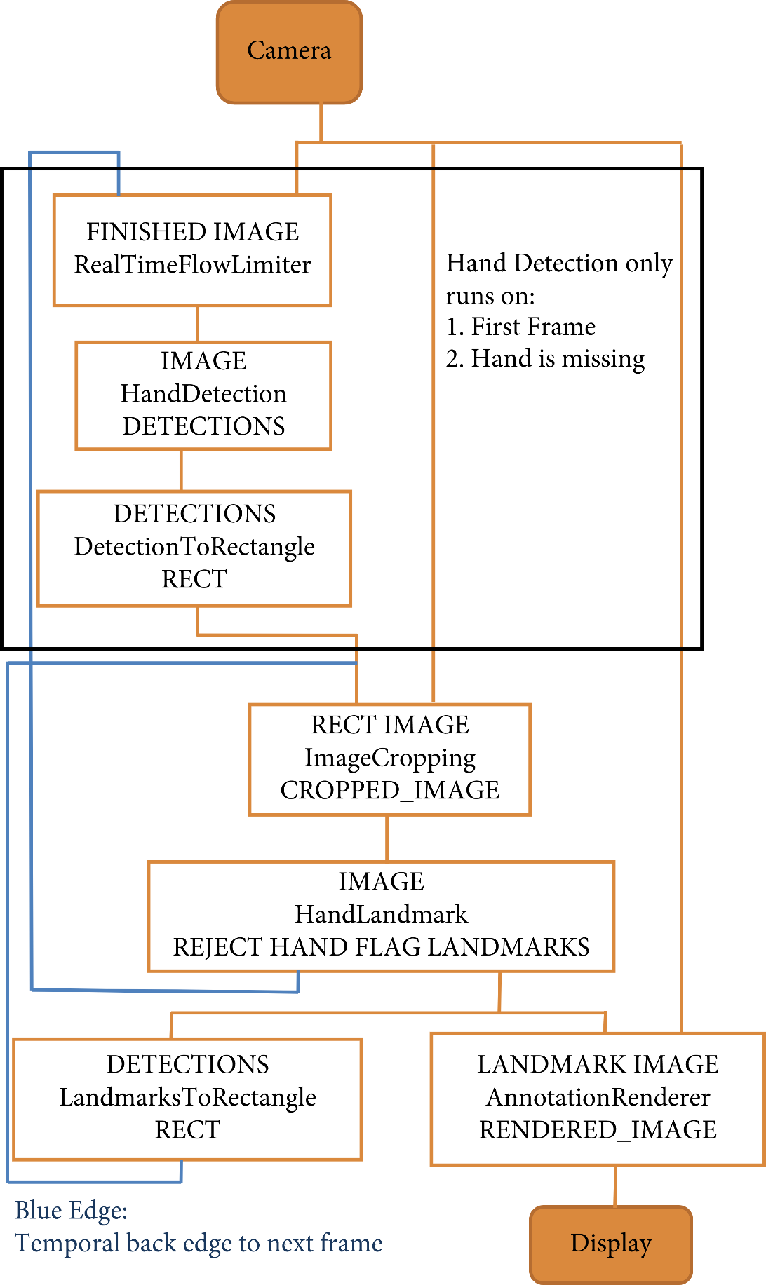

Single-shot detector model is used for detecting and recognizing a hand or palm in real time. The single shot detector model is used by the MediaPipe. First, in the hand detection module, it is first trained for a palm detection model because it is easier to train palms. Furthermore, the nonmaximum suppression works significantly better on small objects such as palms or fists. A model of hand landmark consists of locating 21 joint or knuckle co-ordinates in the hand region, as shown in Figure.

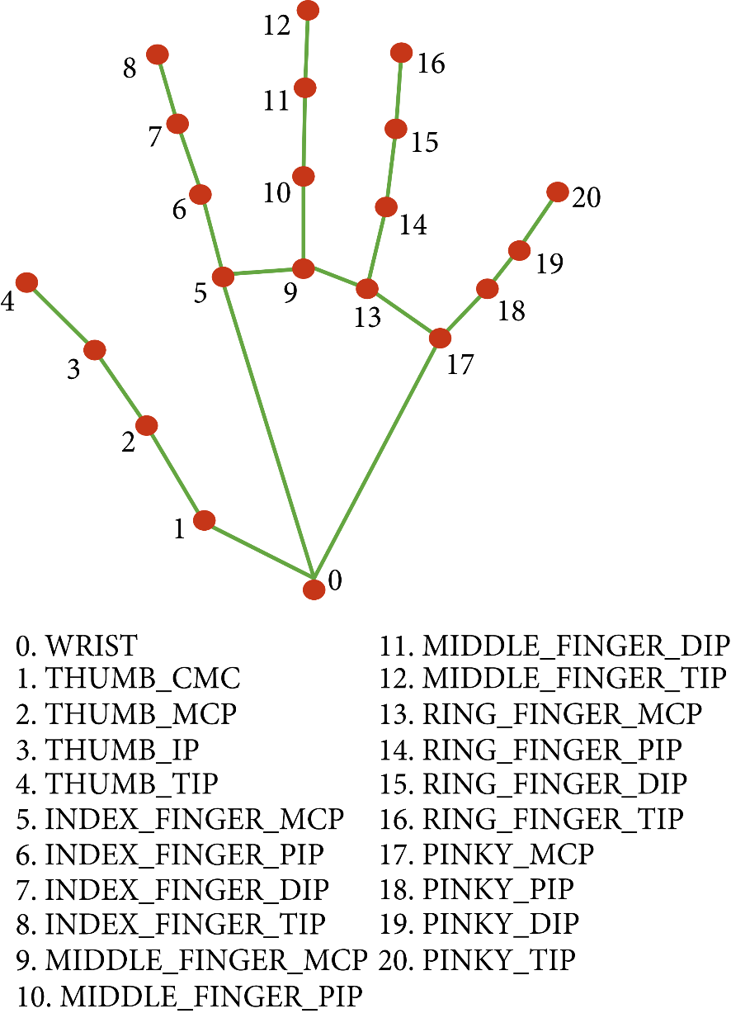

##### OpenCV

OpenCV is a computer vision library which contains image-processing algorithms for object detection.

OpenCV is a library of python programming language, and real-time computer vision applications can be

developed by using the computer vision library. The OpenCV library is used in image and video processing

and also analysis such as face detection and object detection.

#### Methodology

The various functions and conditions used in the system are explained in the flowchart of the real-time AI virtual mouse system in about Figure.

##### The Camera Used in the AI Virtual Mouse System

The proposed AI virtual mouse system is based on the frames that have been captured by the webcam in a

laptop or PC. By using the Python computer vision library OpenCV, the video capture object is created and

the web camera will start capturing video, as shown in Figure . The web camera captures and passes the

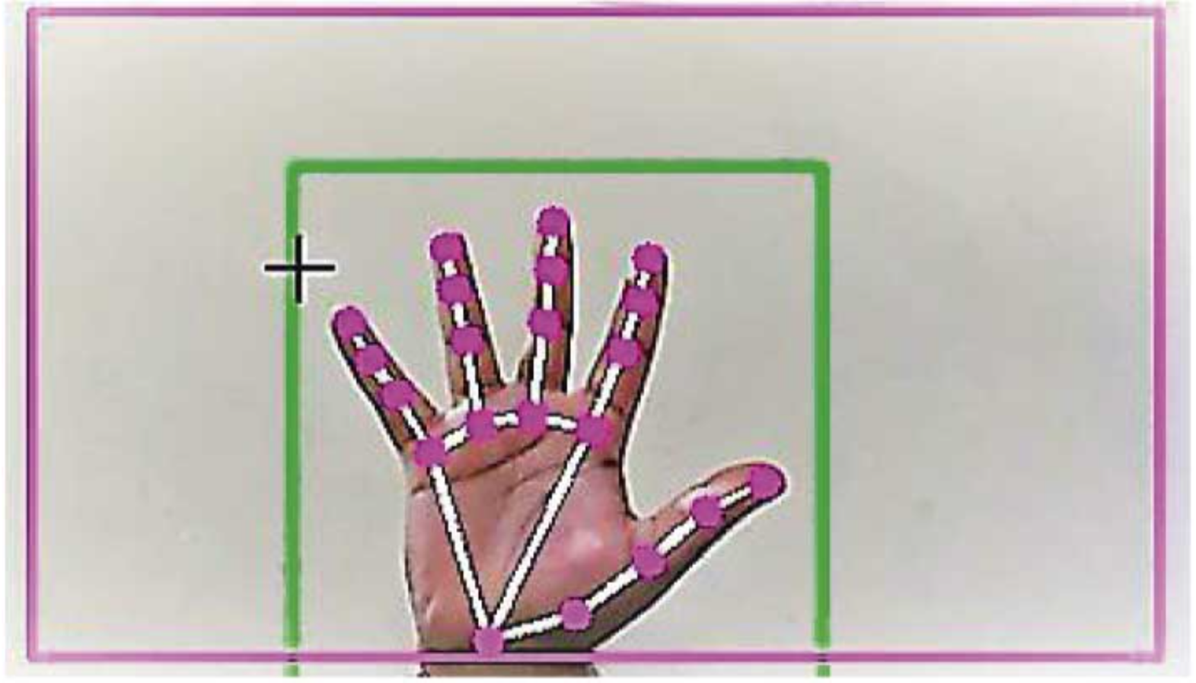frames to the AI virtual system.

##### Capturing the Video and Processing

The AI virtual mouse system uses the webcam where each frame is captured till the termination of the

program. The video frames are processed from BGR to RGB color space to find the hands in the video frame

by frame as shown in the following code:

def findHands(self, img, draw = True):

imgRGB = cv2.cvtColor(img, cv2.COLOR_BGR2RGB)

self.results = self.hands.process(imgRGB)

##### (Virtual Screen Matching) Rectangular Region for Moving through the Window

The AI virtual mouse system makes use of the transformational algorithm, and it converts the co-ordinates

of fingertip from the webcam screen to the computer window full screen for controlling the mouse. When

the hands are detected and when we find which finger is up for performing the specific mouse function, a

rectangular box is drawn with respect to the computer window in the webcam region where we move

throughout the window using the mouse cursor, as shown in Figure.

##### Detecting Which Finger Is Up and Performing the Particular Mouse Function

In this stage, we are detecting which finger is up using the tip Id of the respective finger that we found using

the MediaPipe and the respective co-ordinates of the fingers that are up, as shown in Figure , and according

to that, the particular mouse function is performed.

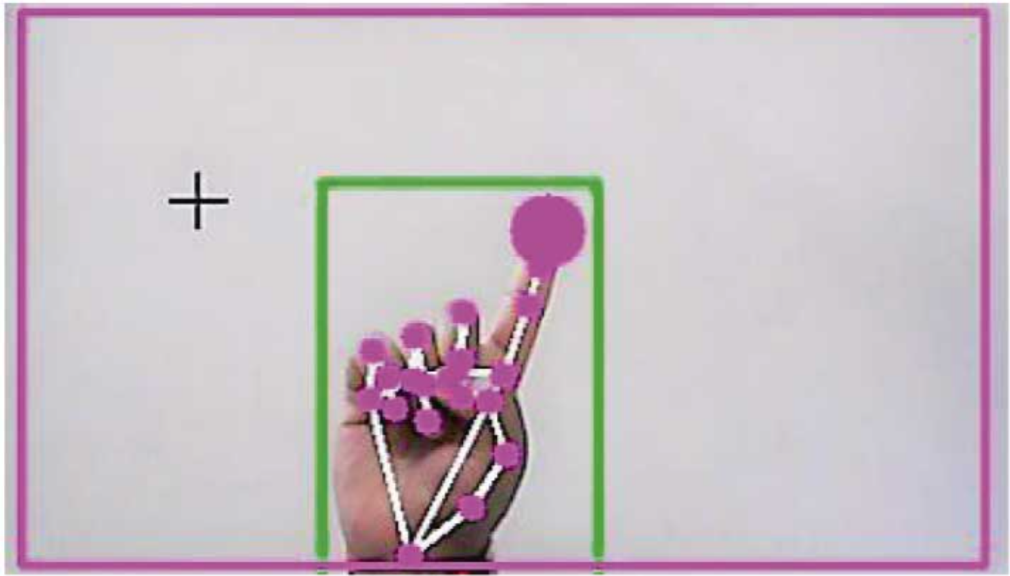

##### Mouse Functions Depending on the Hand Gestures and Hand Tip Detection Using Computer Vision

###### For the Mouse Cursor Moving around the Computer Window

If the index finger is up with tip Id = 1 or both the index finger with tip Id = 1 and the middle finger with tip

Id = 2 are up, the mouse cursor is made to move around the window of the computer using the AutoPy

package of Python, as shown in Figure.

**For the Mouse to Perform Left Button Click**

If both the index finger with tip Id = 1 and the thumb finger with tip Id = 0 are up and the distance between

the two fingers is lesser than 30px, the computer is made to perform the left mouse button click using the

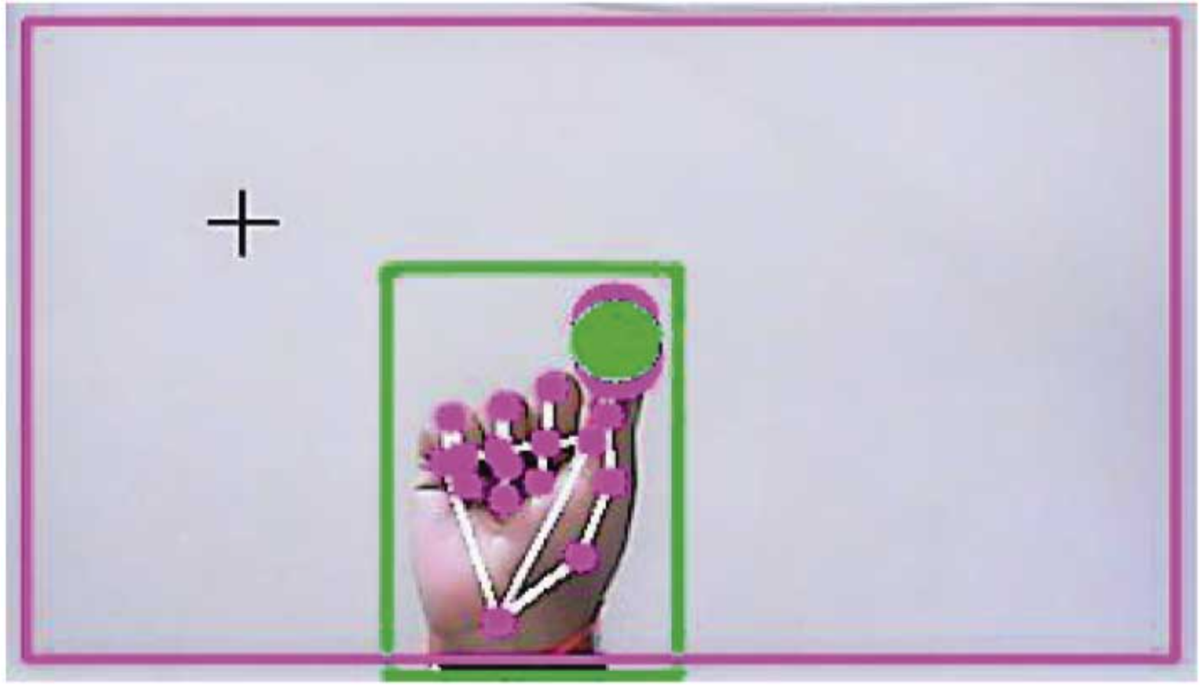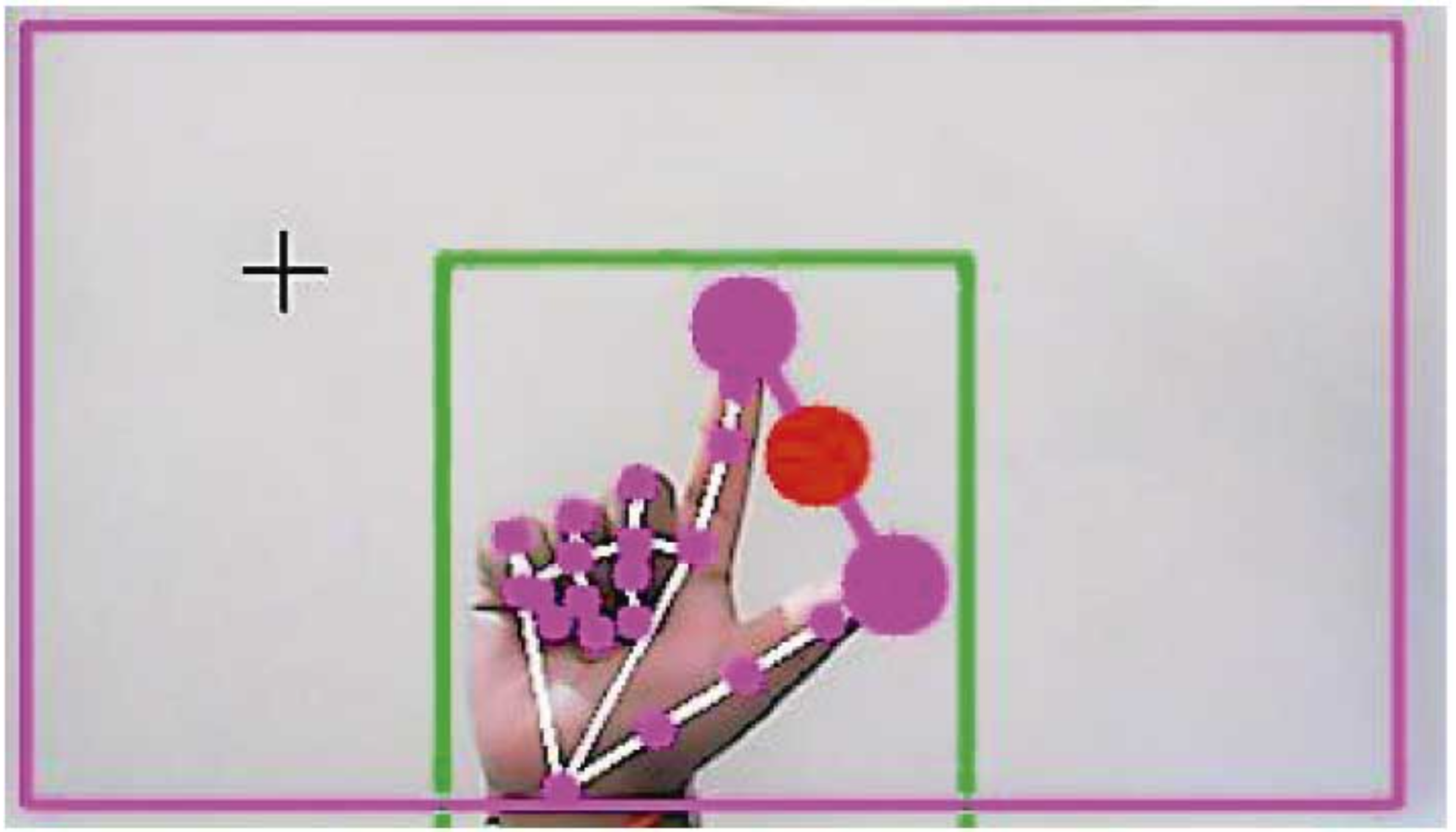pynput Python package, as shown in Figures.

###### For the Mouse to Perform Right Button Click

If both the index finger with tip Id = 1 and the middle finger with tip Id = 2 are up and the distance between

the two fingers is lesser than 40 px, the computer is made to perform the right mouse button click using the

pynput Python package, as shown in Figure.

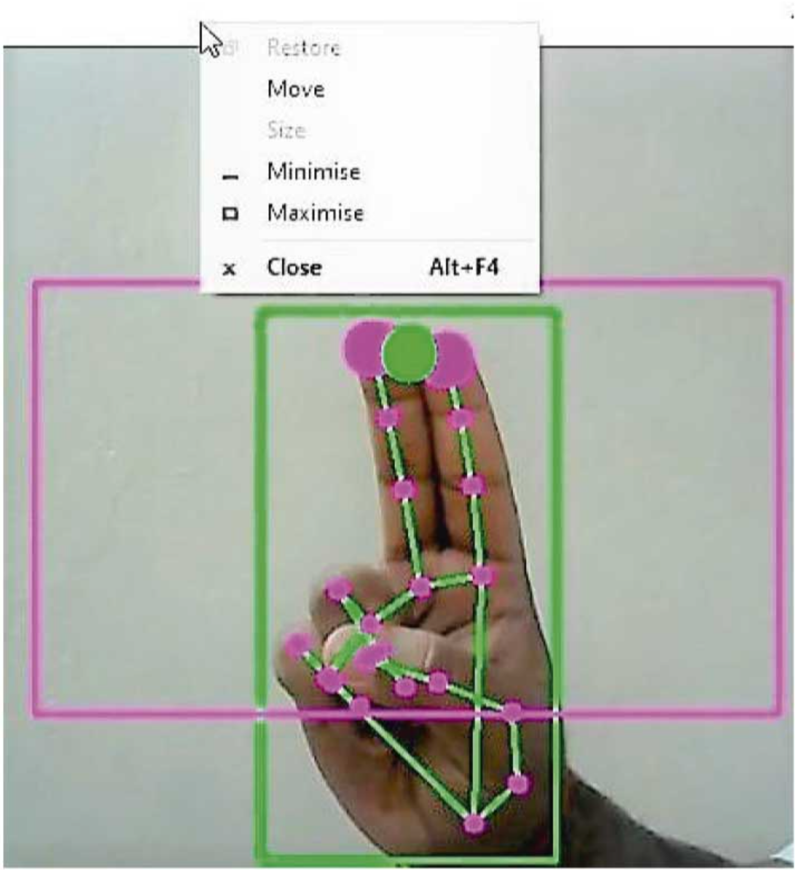

###### For the Mouse to Perform Scroll up Function

If both the index finger with tip Id = 1 and the middle finger with tip Id = 2 are up and the distance between

the two fingers is greater than 40 px and if the two fingers are moved up the page, the computer is made to

perform the scroll up mouse function using the PyAutoGUI Python package, as shown in Figure.

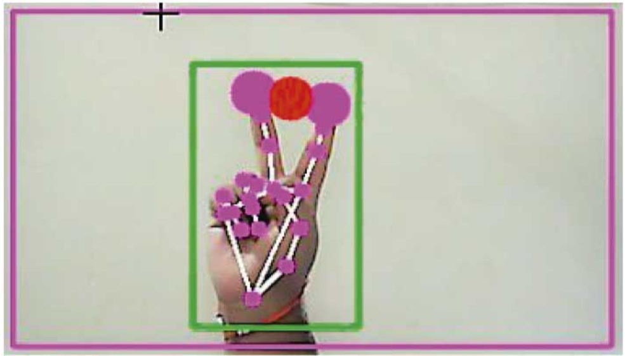

###### For the Mouse to Perform Scroll down Function

If both the index finger with tip Id = 1 and the middle finger with tip Id = 2 are up and the distance between the two fingers is greater than 40px and if the two fingers are moved down the page, the computer is made to perform the scroll down mouse function using the PyAutoGUI Python package, as shown in Figure.

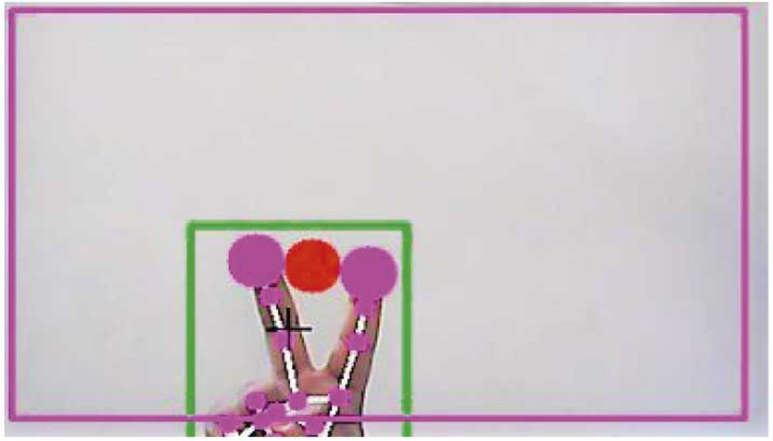

###### For No Action to be Performed on the Screen

If all the fingers are up with tip Id = 0, 1, 2, 3, and 4, the computer is made to not perform any mouse events

in the screen, as shown in Figure.

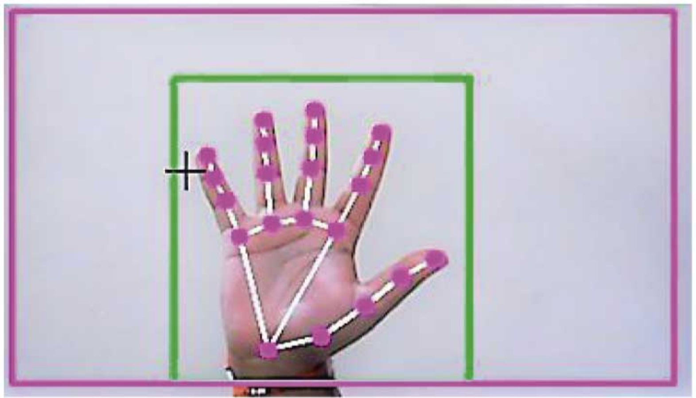

**Result Analysis**

After Implementing the following modules,

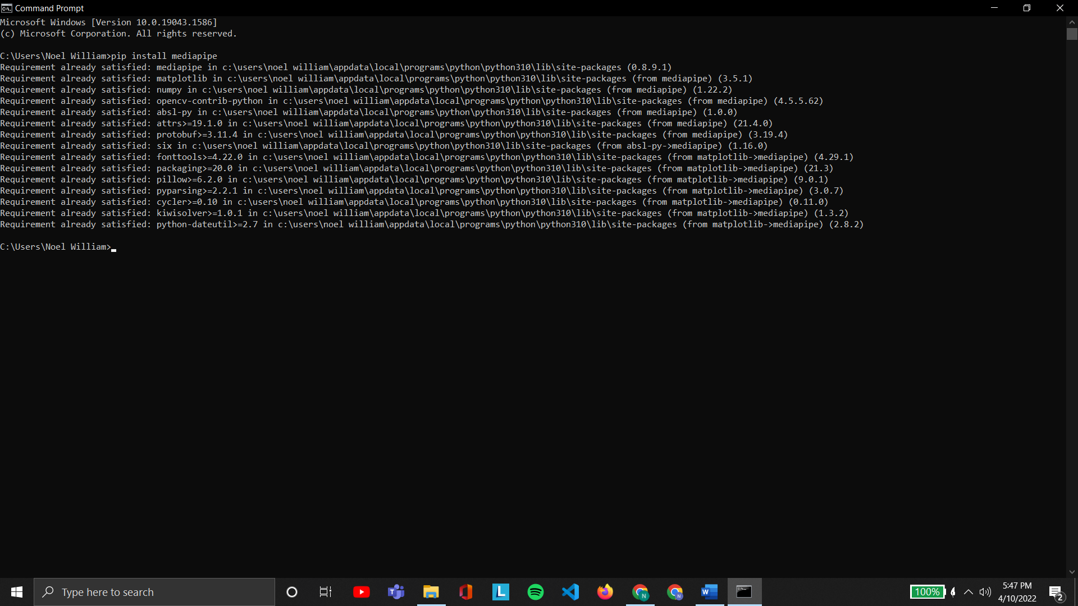**Mediapipe**

**CV2**

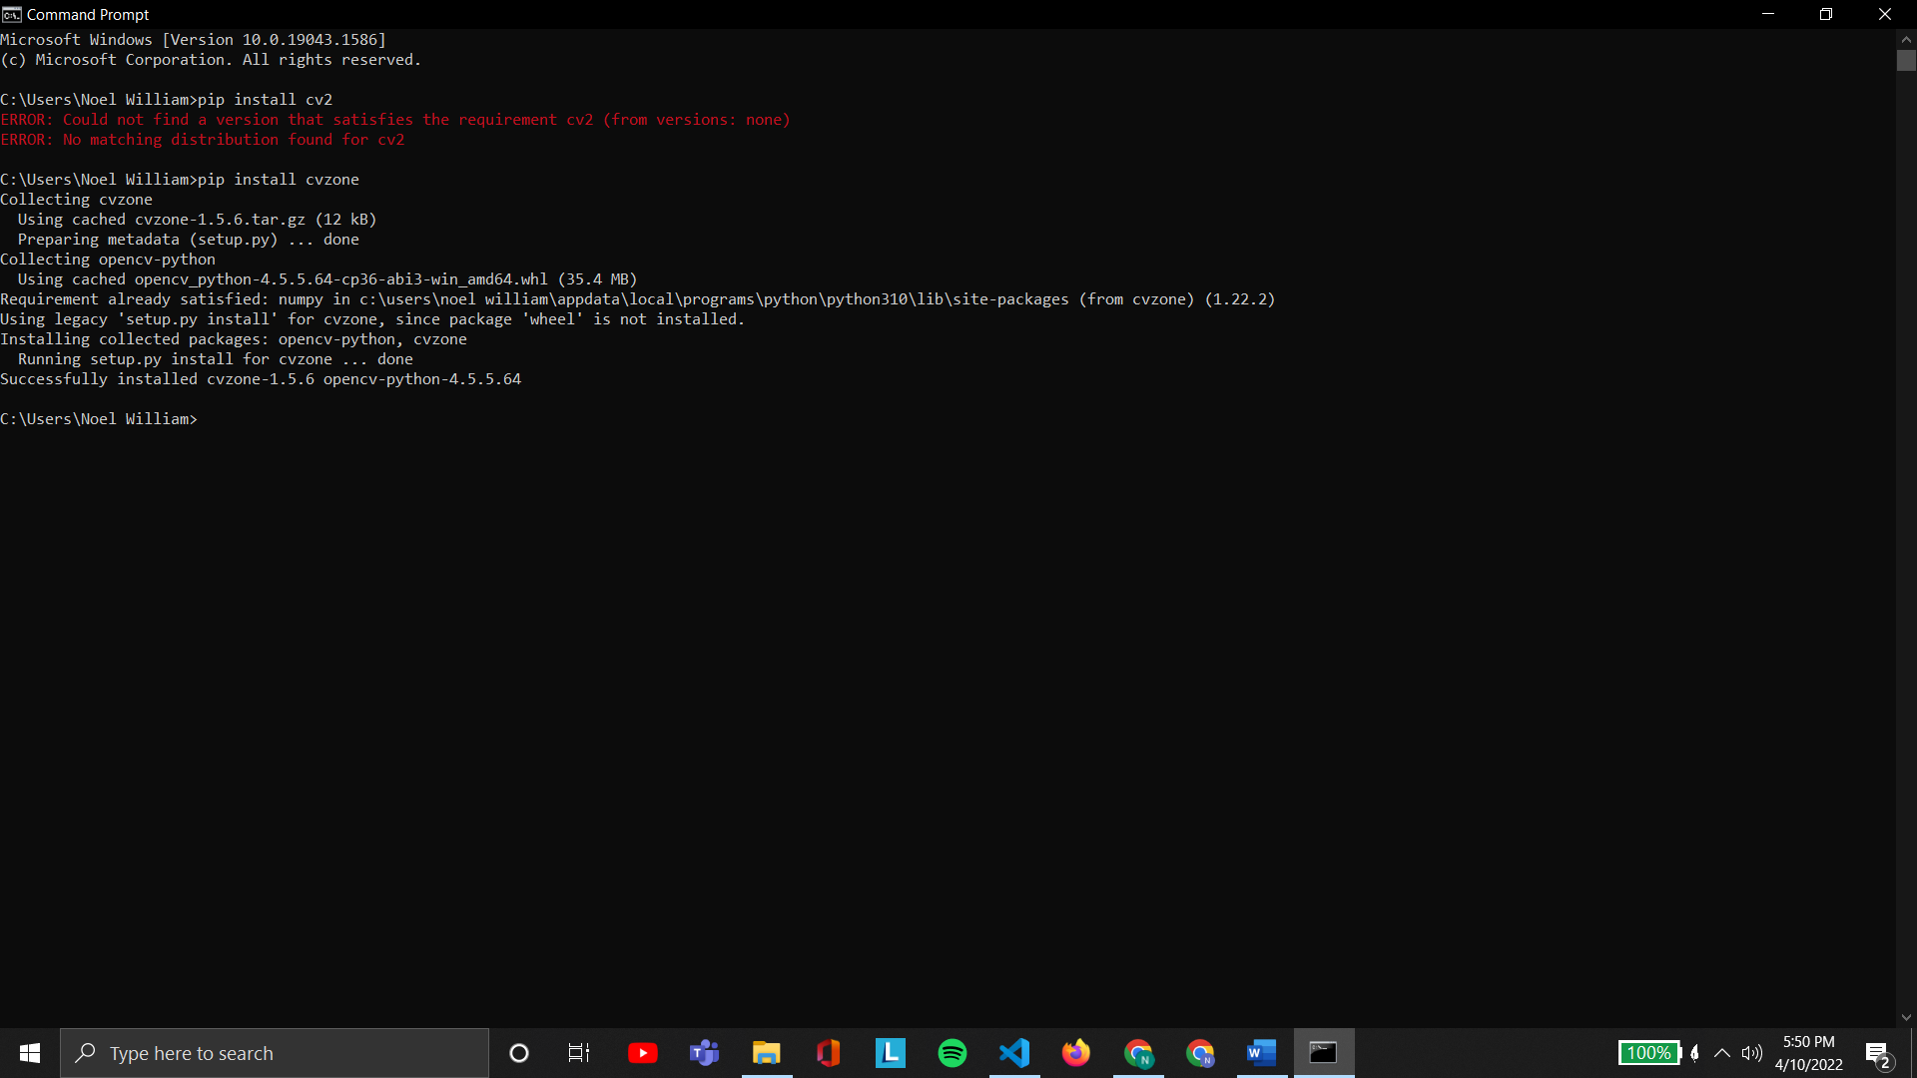

**Numpy**

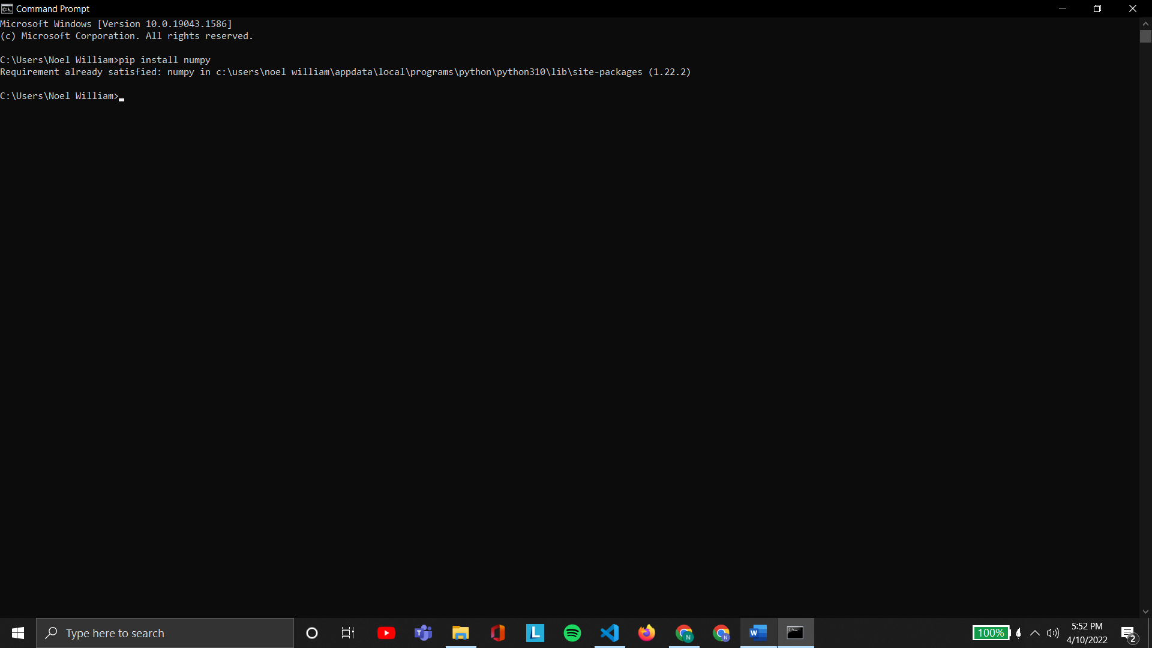

**Autopy**

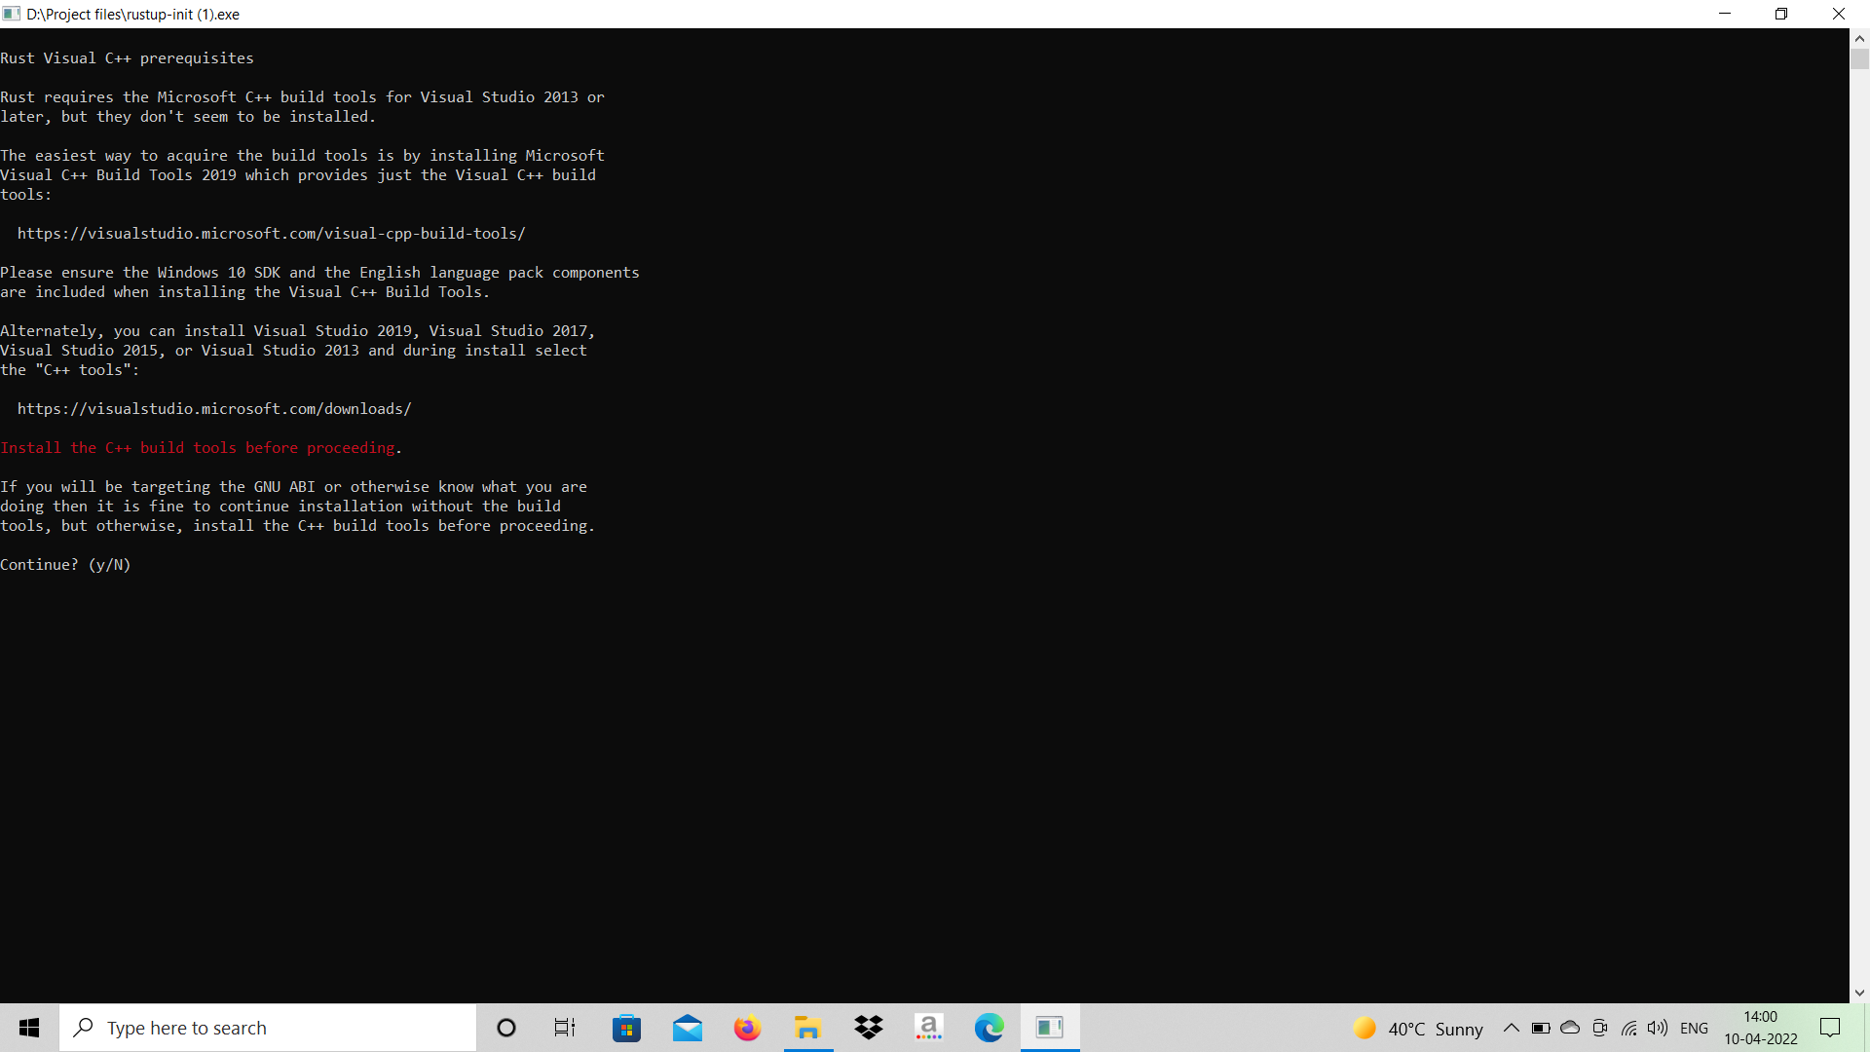As autopy needs rustup to install, we did;

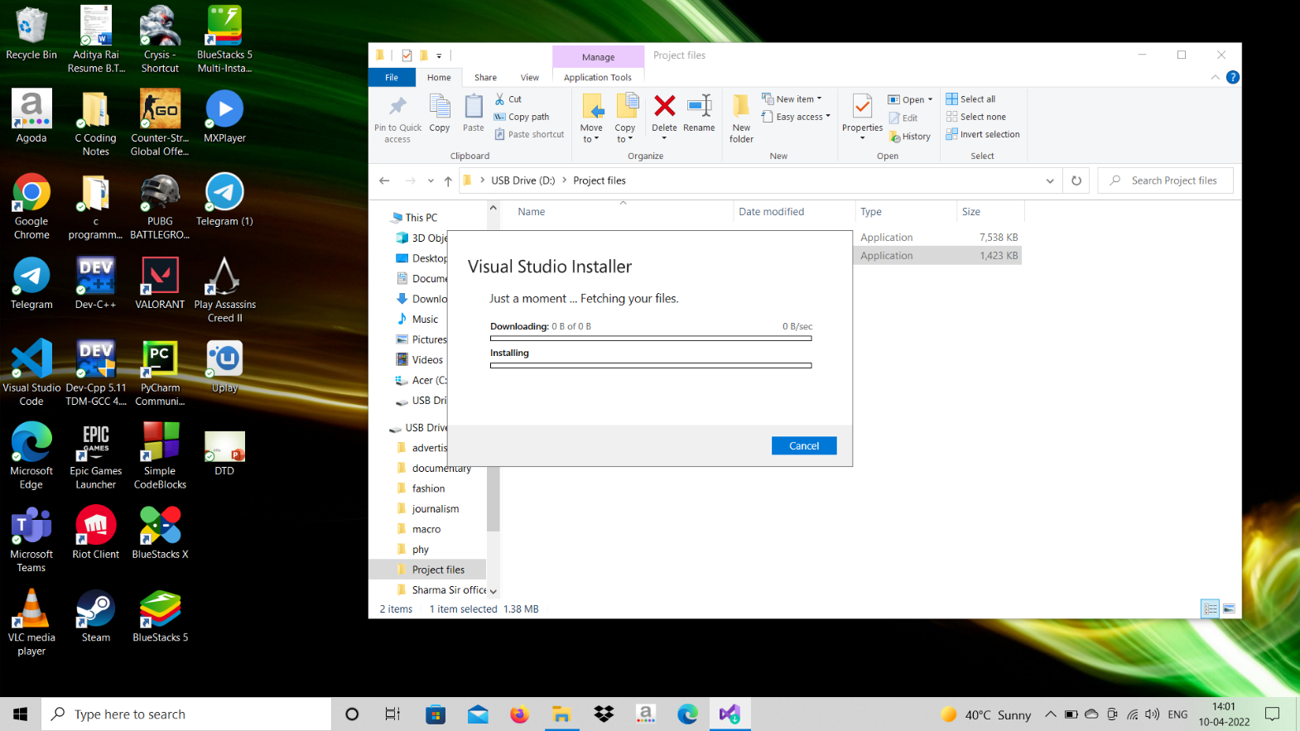Rust up needs visual studio C++ build tools and so installing it,

Setting up build tools,

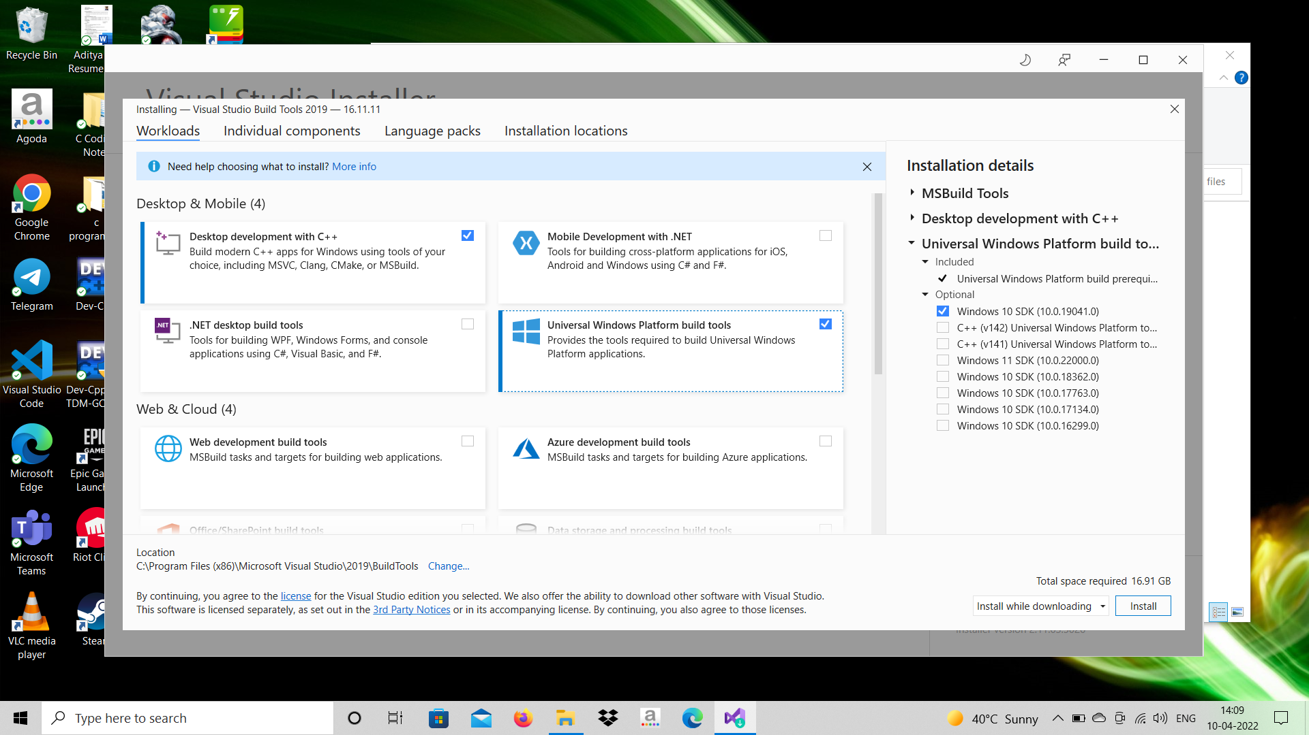

Downloading C++ build tools,

Now finally installing rustup,



After rustup we installed autopy,

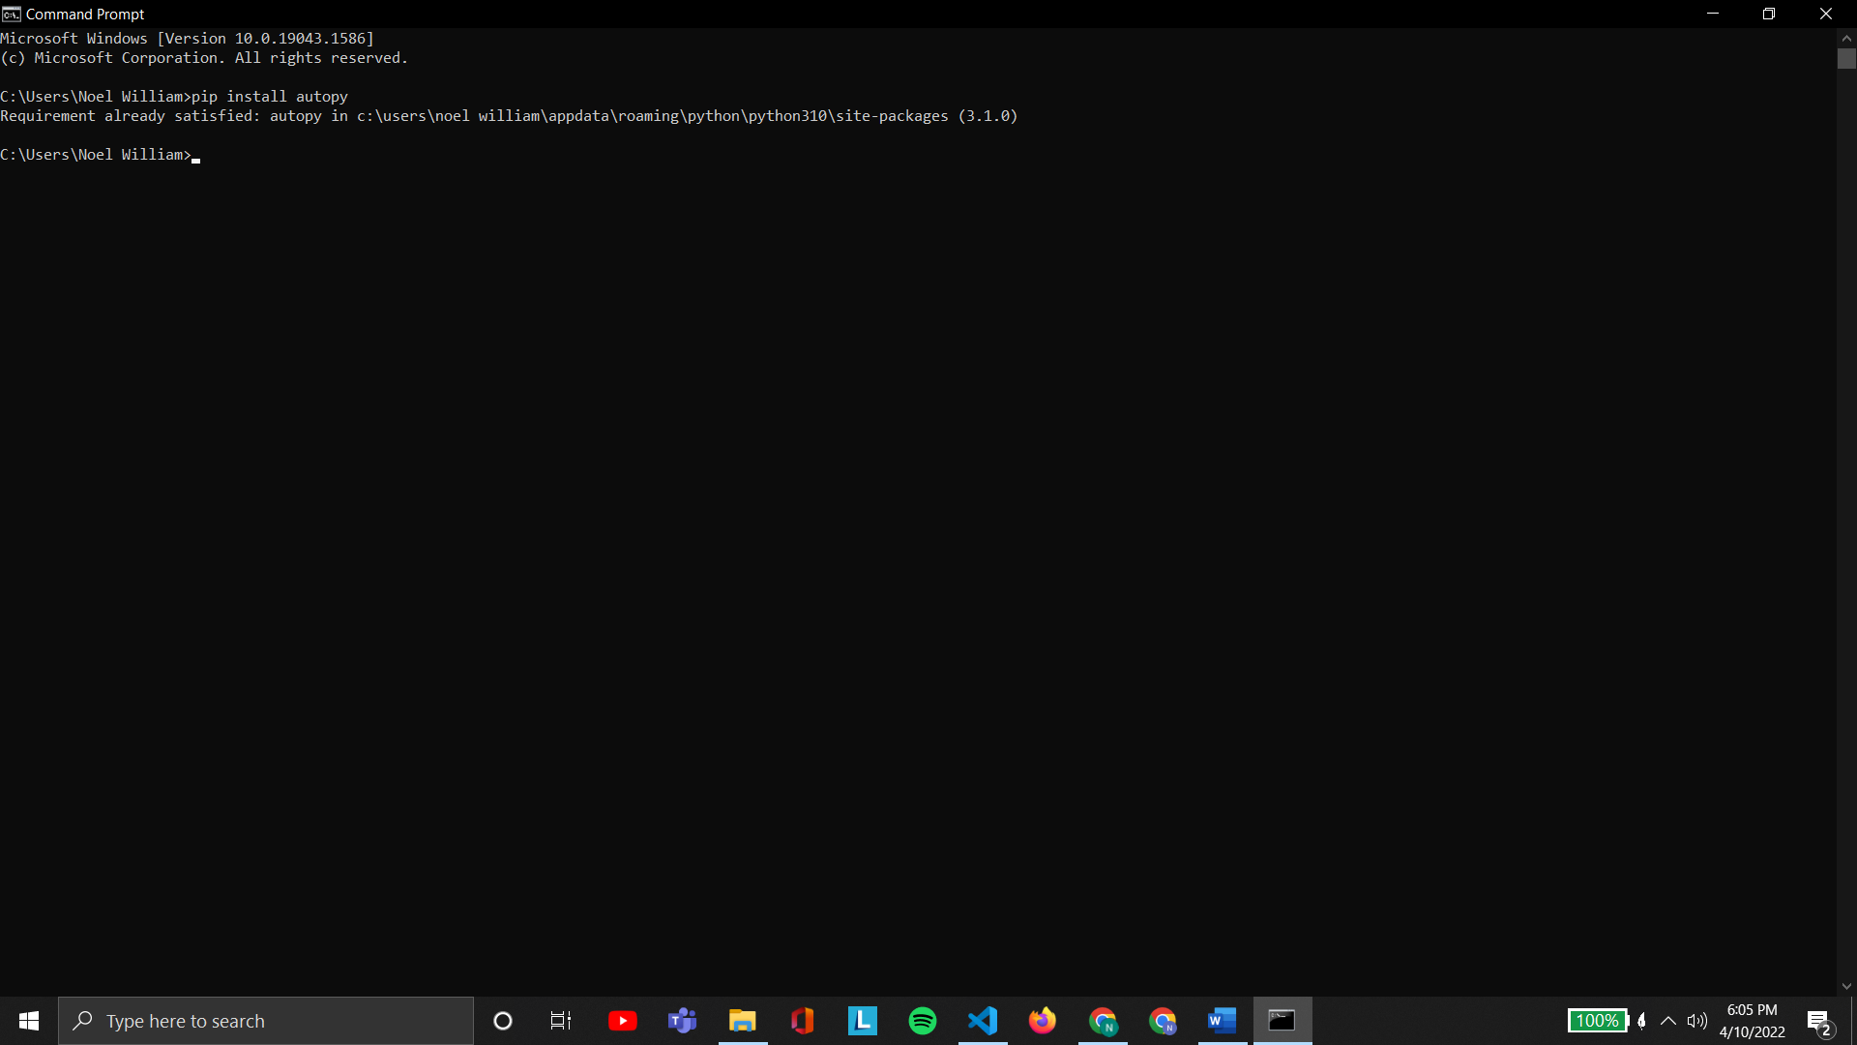

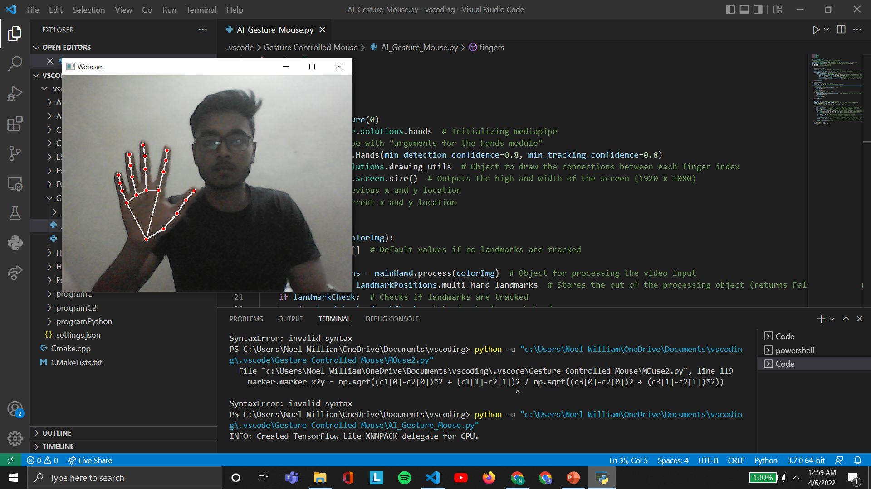Finally after settings up the modules and the code we had our result as AI Hand Gesture Controlled Mouse,

**Future Scope**

The proposed AI virtual mouse has some limitations such as small decrease in accuracy of the right click

mouse function and also the model has some difficulties in executing clicking and dragging to select the

text. These are some of the limitations of the proposed AI virtual mouse system, and these limitations will

be overcome in our future work.

Furthermore, the proposed method can be developed to handle the keyboard functionalities along with the

mouse functionalities virtually which is another future scope of Human-Computer Interaction (HCI).

#### Applications

The AI virtual mouse system is useful for many applications; it can be used to reduce the space for using the

physical mouse, and it can be used in situations where we cannot use the physical mouse. The system

eliminates the usage of devices, and it improves the human-computer interaction.

Major applications:

(i)The proposed model has a greater accuracy of 99% which is far greater than the that of other proposed

models for virtual mouse, and it has many applications

(ii)Amidst the COVID-19 situation, it is not safe to use the devices by touching them because it may result

in a possible situation of spread of the virus by touching the devices, so the proposed AI virtual mouse can be used to control the PC mouse functions without using the physical mouse

(iii)The system can be used to control robots and automation systems without the usage of devices

(iv)2D and 3D images can be drawn using the AI virtual system using the hand gestures

(v)AI virtual mouse can be used to play virtual reality- and augmented reality-based games without the wireless or wired mouse devices

(vi)Persons with problems in their hands can use this system to control the mouse functions in the computer

(vii)In the field of robotics, the proposed system like HCI can be used for controlling robots

(viii)In designing and architecture, the proposed system can be used for designing virtually for prototyping

**Conclusion**

The main objective of the AI virtual mouse system is to control the mouse cursor functions by using the

hand gestures instead of using a physical mouse. The proposed system can be achieved by using a webcam

or a built-in camera which detects the hand gestures and hand tip and processes these frames to perform the

particular mouse functions.

From the results of the model, we can come to a conclusion that the proposed AI virtual mouse system has

performed very well and has a greater accuracy compared to the existing models and also the model

overcomes most of the limitations of the existing systems. Since the proposed model has greater accuracy,

the AI virtual mouse can be used for real-world applications, and also, it can be used to reduce the spread of

COVID-19, since the proposed mouse system can be used virtually using hand gestures without using the

traditional physical mouse.

The model has some limitations such as small decrease in accuracy in right click mouse function and some

difficulties in clicking and dragging to select the text. Hence, we will work next to overcome these

limitations by improving the finger tip detection algorithm to produce more accurate results.

**References**

1. J. Katona, “A review of human–computer interaction and virtual reality research fields in cognitive InfoCommunications,” *Applied Sciences*, vol. 11, no. 6, p. 2646, 2021.View at: [Publisher Site](https://doi.org/10.3390/app11062646) | [Google Scholar](https://scholar.google.com/scholar_lookup?title=A%20review%20of%20human%E2%80%93computer%20interaction%20and%20virtual%20reality%20research%20fields%20in%20cognitive%20InfoCommunications&author=J.%20Katona&publication_year=2021)
2. D. L. Quam, “Gesture recognition with a DataGlove,” *IEEE Conference on Aerospace and Electronics*, vol. 2, pp. 755–760, 1990.View at: [Publisher Site](https://doi.org/10.1109/NAECON.1990.112862) | [Google Scholar](https://scholar.google.com/scholar_lookup?title=Gesture%20recognition%20with%20a%20DataGlove&author=D.%20L.%20Quam&publication_year=1990)
3. D.-H. Liou, D. Lee, and C.-C. Hsieh, “A real time hand gesture recognition system using motion history image,” in *Proceedings of the 2010 2nd International Conference on Signal Processing Systems*, IEEE, Dalian, China, July 2010.View at: [Publisher Site](https://doi.org/10.1109/ICSPS.2010.5555462) | [Google Scholar](https://scholar.google.com/scholar_lookup?title=A%20real%20time%20hand%20gesture%20recognition%20system%20using%20motion%20history%20image&author=D.-H.%20Liou&author=D.%20Lee&author=&author=C.-C.%20Hsieh)
4. S. U. Dudhane, “Cursor control system using hand gesture recognition,” *IJARCCE*, vol. 2, no. 5, 2013.View at: [Google Scholar](https://scholar.google.com/scholar_lookup?title=Cursor%20control%20system%20using%20hand%20gesture%20recognition&author=S.%20U.%20Dudhane&publication_year=2013)
5. K. P. Vinay, “Cursor control using hand gestures,” *International Journal of Critical Accounting*, vol. 0975–8887, 2016.View at: [Google Scholar](https://scholar.google.com/scholar_lookup?title=Cursor%20control%20using%20hand%20gestures&author=K.%20P.%20Vinay&publication_year=2016)
6. L. Thomas, “Virtual mouse using hand gesture,” *International Research Journal of Engineering and Technology (IRJET*, vol. 5, no. 4, 2018.View at: [Google Scholar](https://scholar.google.com/scholar_lookup?title=Virtual%20mouse%20using%20hand%20gesture&author=L.%20Thomas&publication_year=2018)
7. P. Nandhini, J. Jaya, and J. George, “Computer vision system for food quality evaluation—a review,” in *Proceedings of the 2013 International Conference on Current Trends in Engineering and Technology (ICCTET)*, pp. 85–87, Coimbatore, India, July 2013.View at: [Publisher Site](https://doi.org/10.1109/ICCTET.2013.6675916) | [Google Scholar](https://scholar.google.com/scholar_lookup?title=Computer%20vision%20system%20for%20food%20quality%20evaluation%E2%80%94a%20review&author=P.%20Nandhini&author=J.%20Jaya&author=&author=J.%20George)
8. J. Jaya and K. Thanushkodi, “Implementation of certain system for medical image diagnosis,” *European Journal of Scientific Research*, vol. 53, no. 4, pp. 561–567, 2011.View at: [Google Scholar](https://scholar.google.com/scholar_lookup?title=Implementation%20of%20certain%20system%20for%20medical%20image%20diagnosis&author=J.%20Jaya%20&author=K.%20Thanushkodi&publication_year=2011)
9. P. Nandhini and J. Jaya, “Image segmentation for food quality evaluation using computer vision system,” *International Journal of Engineering Research and Applications*, vol. 4, no. 2, pp. 1–3, 2014.View at: [Google Scholar](https://scholar.google.com/scholar_lookup?title=Image%20segmentation%20for%20food%20quality%20evaluation%20using%20computer%20vision%20system&author=P.%20Nandhini%20&author=J.%20Jaya&publication_year=2014)
10. J. Jaya and K. Thanushkodi, “Implementation of classification system for medical images,” *European Journal of Scientific Research*, vol. 53, no. 4, pp. 561–569, 2011.View at: [Google Scholar](https://scholar.google.com/scholar_lookup?title=Implementation%20of%20classification%20system%20for%20medical%20images&author=J.%20Jaya%20&author=K.%20Thanushkodi&publication_year=2011)
11. J. T. Camillo Lugaresi, “MediaPipe: A Framework for Building Perception Pipelines,” 2019, <https://arxiv.org/abs/1906.08172>.View at: [Google Scholar](https://scholar.google.com/scholar_lookup?title=MediaPipe:%20A%20Framework%20for%20Building%20Perception%20Pipelines&author=J.%20T.%20Camillo%20Lugaresi&publication_year=2019)
12. Google, MP, <https://ai.googleblog.com/2019/08/on-device-real-time-hand-tracking-with.html>.
13. V. Bazarevsky and G. R. Fan Zhang. On-Device, MediaPipe for Real-Time Hand Tracking.
14. K. Pulli, A. Baksheev, K. Kornyakov, and V. Eruhimov, “Realtime computer vision with openCV,” *Queue*, vol. 10, no. 4, pp. 40–56, 2012.View at: [Publisher Site](https://doi.org/10.1145/2181796.2206309) | [Google Scholar](https://scholar.google.com/scholar_lookup?title=Realtime%20computer%20vision%20with%20openCV&author=K.%20Pulli&author=A.%20Baksheev&author=K.%20Kornyakov&author=&author=V.%20Eruhimov&publication_year=2012)
15. [https://www.tutorialspoint.com](https://www.tutorialspoint.com/)› opencv.
16. D.-S. Tran, N.-H. Ho, H.-J. Yang, S.-H. Kim, and G. S. Lee, “Real-time virtual mouse system using RGB-D images and fingertip detection,” *Multimedia Tools and ApplicationsMultimedia Tools and Applications*, vol. 80, no. 7, pp. 10473–10490, 2021.View at: [Publisher Site](https://doi.org/10.1007/s11042-020-10156-5) | [Google Scholar](https://scholar.google.com/scholar_lookup?title=Real-time%20virtual%20mouse%20system%20using%20RGB-D%20images%20and%20fingertip%20detection&author=D.-S.%20Tran&author=N.-H.%20Ho&author=H.-J.%20Yang&author=S.-H.%20Kim&author=&author=G.%20S.%20Lee&publication_year=2021)
17. A. Haria, A. Subramanian, N. Asokkumar, S. Poddar, and J. S. Nayak, “Hand gesture recognition for human computer interaction,” *Procedia Computer Science*, vol. 115, pp. 367–374, 2017.View at: [Publisher Site](https://doi.org/10.1016/j.procs.2017.09.092) | [Google Scholar](https://scholar.google.com/scholar_lookup?title=Hand%20gesture%20recognition%20for%20human%20computer%20interaction&author=A.%20Haria&author=A.%20Subramanian&author=N.%20Asokkumar&author=S.%20Poddar&author=&author=J.%20S.%20Nayak&publication_year=2017)
18. K. H. Shibly, S. Kumar Dey, M. A. Islam, and S. Iftekhar Showrav, “Design and development of hand gesture based virtual mouse,” in *Proceedings of the 2019 1st International Conference on Advances in Science, Engineering and Robotics Technology (ICASERT)*, pp. 1–5, Dhaka, Bangladesh, May 2019.View at: [Publisher Site](https://doi.org/10.1109/ICASERT.2019.8934612) | [Google Scholar](https://scholar.google.com/scholar_lookup?title=Design%20and%20development%20of%20hand%20gesture%20based%20virtual%20mouse&author=K.%20H.%20Shibly&author=S.%20Kumar%20Dey&author=M.%20A.%20Islam&author=&author=S.%20Iftekhar%20Showrav)

# Formatting details:

# Chapter Name: 16pts Times new roman

# Subheading: 14pts Times new roman

# Content: 12pts Times new roman

# Line spacing: 1.5

# Alignment: justify

1. The first page should be in color print
2. The certificate should have the PU logo as a watermark - **50% fade & colored**
3. Add page no and specify in Index. Page no will start from **Chapter-1 Introduction**(actual content).
4. Minor details like course name, session, sem no, year no, specialization need to be updated according to your course.

MCA- Master of Computer Applications

BCA- Bachelor of Computer Applications

B.Tech- Bachelor of Technology

Specialization like - AI, Cyber Security, General, etc

**NOTE:** To add a watermark, make a separate word document that has only a certificate page with the watermark. Get a separate print. Add it to the other prints before spiral binding.